Exp7: Heat engine cycle

20210816 Phattharaphol Laokulwanich

**Abstract**

The heat engine undergoes a full cycle of 4 thermodynamic processes. The system consists of piston containing gas for lifting mass, and the can connected with the tube. The pressure can measure directly from sensor in the pistol, and the volume is calculated from the product of area and change of pistol’s height. The hot and cold water are used as hot and cold reservoir. The results show that the actual efficiency is much less than the expected from theory, and there’s some loss of energy while the gas does work.

**Introduction**

Heat engine is the system that does work by bringing working fluid from higher temperature to lower temperature. Some thermal energy upon transferring fluid from hot reservoir to cold reservoir are convert into work. In this experiment, our heat engine includes the air in the cylinder which will expand when the attached can is put in the water. The work from heat engine is used to lift the weight. The cycle complete by put the can into cold water, which will return the gas in the cylinder to its initial state.

**Theory**

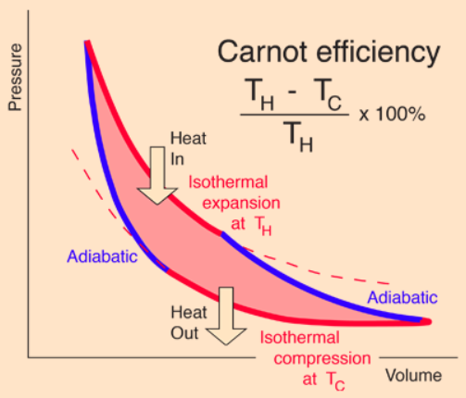

The Carnot cycle in this experiment have 4 main processes:

1. Isothermal gas compression. The work is done on gas and the heat exhausted.
$$W=nRT_{C}\text{ln}\left(\frac{V_{f}}{V_{i}}\right)=Q$$

2. Isobaric gas expansion. The heat is added to the system, the piston is free to move so the pressure remain constant.
$$W=P∆V, Q=nc_{p}∆T$$

3. Isothermal gas expansion. The gas expands and doing work form added heat.
$$W=nRT_{H}\text{ln}\left(\frac{V_{f}}{V_{i}}\right)=Q$$

4. Isobaric gas compression. The heat exhausted and the gas is back to initial state.

$$W=P∆V, Q=nc_{p}∆T$$

The efficiency of heat engine is the ratio of work done by gas to the heat absorbed

$$eff=\frac{Q_{H}-Q_{C}}{Q_{H}}=1-\frac{Q_{C}}{Q_{H}}$$

$$Q_{c}=\frac{T_{C}}{T_{H}}Q_{H} ; eff=1-\frac{T_{C}}{T_{H}}$$

**Method**

1. Attach the heat engine to the rod. The Heat Engine should be oriented with the piston end up and should be positioned near the bottom of the rod stand.
2. Attach the Rotary Motion Sensor to the top of the rod stand. Tie one end of the string to the shaft of the piston, the other end with the mass hanger.
3. Position the piston 2 or 3 cm from the bottom of the cylinder. Connect the tube from the can and pressure censor with 2 ports of the heat engine.
4. Fill 2 containers with hot and cold water and measure the temperature.
5. Perform the cycle:

* A → B: Place a 200g mass on the platform.
* B → C: Move the can from the cold bath to the hot bath.
* C → D: Remove the 200g mass from the platform.
* D → A: Move the can from the hot bath to the cold bath.

1. Analyze and calculate the work done by gas and the efficiency of the engine. Compare the theory to the actual value.

**Results**

|  |  |
| --- | --- |
| diameter of can | 38.07 mm |
| height of can | 130 mm |
| mass of mass | 202.1 g |
| Piston diameter | 32.5 mm |
| piston initial height | 5.2 cm |
| temperature cold water | 299 K |
| temperature hot water | 369 K |

B

D

C

A

Edge/turning points

|  |  |  |
| --- | --- | --- |
|  | Volume (m3) | Relative pressure (kPa) |
| A | 1.91 x 10-4 | -7.447 |
| B | 1.87 x 10-4 | 252.9 |
| C | 2.04 x 10-4 | 252 |
| D | 2.08 x 10-4 | -7.141 |

The experimental efficiency

$W=nR{(T}_{H}\text{ln}\left(\frac{V_{D}}{V_{C}}\right)+T_{C}\text{ln}\left(\frac{V_{B}}{V_{A}}\right))$; $Q_{H}=nR{(T}_{H}\text{ln}\left(\frac{V_{D}}{V_{C}}\right)+\frac{7}{2}(T_{H}-T_{C}))$

$eff=\frac{W}{Q_{H}}×100\%=\frac{T_{H}\text{ln}\left(\frac{V_{D}}{V_{C}}\right)+T_{C}\text{ln}\left(\frac{V_{B}}{V_{A}}\right)}{T_{H}\text{ln}\left(\frac{V_{D}}{V_{C}}\right)+\frac{7}{2}(T_{H}-T_{C})}×100\%=0.33\%$

Actual work done by the cycle

$W=mg∆h=0.202(9.8)(0.0209)=0.0414 \text{J}$

**Discussion**

The ideal efficiency of the engine: $eff=\left(1-\frac{T_{C}}{T_{H}}\right)×100\%=18.97\%$.The actual efficiency is 0.33%, which is only $\frac{0.33}{18.97}×100=1.73\%$ of the expected efficiency. The error may be caused by that the gas is not ideal, and the rapid change of temperature which lead to non-quasi static process.

The ideal work of the Carnot cycle, or the work done by gas is the area under curve (assume parallelogram shape) $W=∆P∆V=4.403 \text{J}$. Compare to the actual work done (0.0414 J), the system would loss 99% of its work. Since the pressure and volume get back to the initial state when complete the cycle, so there’s no major issue like leakage in the setup. The error may come from the wrong identification of the turning point. It is very hard to identify because there’s lot of data with the similar information around that point, this would make inaccuracy of identifying it. Consider the pressure, its value does not compatible with the size of the actual experiment. The scaling might be 100x of the actual value. If that the case, then the actual work done will have 6% error compare to the new scaled ideal work.

**Conclusion**

The heat engine was pass through a cycle of thermodynamics processes, isothermal compression, isobaric expansion, isothermal expansion, and isobaric compression. The gas did the total work of lifting a mass on the pistol. The efficiency and work done by gas are calculated, and compared the actual and theoretical values. The actual efficiency is much less than the theoretical value since the gas is not ideal and the change of state may not meet the theory. Also, the value of actual work done is less than the work done by gas, so there’s some loss of energy.

**References**

1. https://genphylab.kaist.ac.kr/
2. https://phys.libretexts.org/Bookshelves/University_Physics/Book%3A_University_Physics_(OpenStax)/Book%3A_University_Physics_II_-_Thermodynamics_Electricity_and_Magnetism_(OpenStax)/03%3A_The_First_Law_of_Thermodynamics/3.05%3A_Thermodynamic_Processes